Тема № 5
Программы для обработки текстовых файлов
Цель работы: получить практические навыки создания и подключения собственной динамической библиотеки, разработки алгоритмов сложного поиска и методов по обработке текстовых файлов.
Задача (16 вариант):
Найти в словаре слова, которые являются словоформами введенного слова. Могут включать заданное слово с добавленной к нему приставкой или окончанием, причем в корне слова одна буква может быть изменена, например: слово «ход» - словоформы «вход», «выход», «входить», «выходить», «заход», «исход», «хождение» и др. Результаты сохранить в отдельный текстовый файл.
Задание 1:
Код класса
using System;
using System.Collections.Generic;
using System.Linq;
using System.Text;
using System.Threading.Tasks;

namespace Task5
{
internal class Slovar
{
private List<string> words = new List<string>();
private string filename;
private int count;

public Slovar() { }

public Slovar(string filename)
{
this.filename = filename;
LoadDictionary(filename);
count = words.Count;
}

public int Count { get { return count; } }

public void LoadDictionary(string path)
{
try
{
words.Clear();
using (StreamReader reader = new StreamReader(path, Encoding.UTF8))
{
string line;
while ((line = reader.ReadLine()) != null)
{
if (!string.IsNullOrWhiteSpace(line))
words.Add(line.Trim());
}
}
count = words.Count;
}
catch (Exception ex)
{
throw new Exception("Error accessing file: " + ex.Message);
}
}

public void SaveDictionary(string path)
{
try
{
using (StreamWriter writer = new StreamWriter(path, false, Encoding.UTF8))
{
foreach (string word in words)
writer.WriteLine(word);
}
}
catch (Exception ex)
{
throw new Exception("Error saving file: " + ex.Message);
}
}

public bool AddWord(string word)
{
if (string.IsNullOrWhiteSpace(word)) return false;
string trimmed = word.Trim();
if (!words.Contains(trimmed))
{
words.Add(trimmed);
count = words.Count;
return true;
}
return false;
}

public bool DeleteWord(string word)
{
if (words.Remove(word))
{
count = words.Count;
return true;
}
return false;
}

public List<string> GetAllWords() => new List<string>(words);

public bool Contains(string word) => words.Contains(word);

public List<string> GetWordsStartingWith(string prefix)
{
if (string.IsNullOrEmpty(prefix))
return GetAllWords();
return words.Where(w => w.StartsWith(prefix, StringComparison.OrdinalIgnoreCase)).ToList();
}

private static int LevenshteinDistance(string s, string t)
{
int n = s.Length, m = t.Length;
int[,] d = new int[n + 1, m + 1];
if (n == 0) return m;
if (m == 0) return n;

for (int i = 0; i <= n; d[i, 0] = i++) ;
for (int j = 0; j <= m; d[0, j] = j++) ;

for (int i = 1; i <= n; i++)
{
for (int j = 1; j <= m; j++)
{
int cost = (s[i - 1] == t[j - 1]) ? 0 : 1;
d[i, j] = Math.Min(
Math.Min(d[i - 1, j] + 1, d[i, j - 1] + 1),
d[i - 1, j - 1] + cost);
}
}
return d[n, m];
}

public List<string> FuzzySearch(string pattern, int maxDistance = 3)
{
if (string.IsNullOrEmpty(pattern))
return new List<string>();

return words.Where(w => LevenshteinDistance(w, pattern) <= maxDistance).ToList();
}

public List<string> FindWordForms(string pattern)
{
if (string.IsNullOrEmpty(pattern))
return new List<string>();

List<string> result = new List<string>();
int patternLen = pattern.Length;

foreach (string word in words)
{
bool found = false;
int wordLen = word.Length;

for (int subLen = patternLen - 1; subLen <= patternLen + 1; subLen++)
{
if (subLen < 1 || subLen > wordLen) continue;

for (int start = 0; start <= wordLen - subLen; start++)
{
string sub = word.Substring(start, subLen);
if (LevenshteinDistance(pattern, sub) <= 1)
{
result.Add(word);
found = true;
break;
}
}
if (found) break;
}
}
return result;
}
}
}
Задание 2:
Код юнит-теста
using Microsoft.VisualStudio.TestTools.UnitTesting;
using System;
using Task5;

namespace UnitTestProject1
{
[TestClass]
public class UnitTest1
{
[TestMethod]
public void TestMethod1()
{
var slovar = new Slovar();
slovar.AddWord("собака");
slovar.AddWord("стол");

var result = slovar.FindWordForms("ход");
Assert.Empty(result);
}
}
}
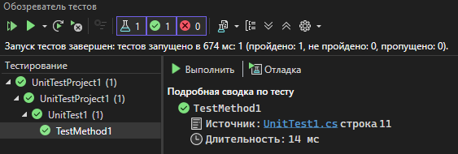
Рис.1 – Пройденный юнит-тест
Задание 3
Код главной формы
namespace Task5
{
public partial class MainForm : Form
{
private Slovar currentDictionary;
private string currentFilePath;
private bool isMainDictionary = false;
public MainForm()
{
InitializeComponent();
currentDictionary = new Slovar();
}

private void label1_Click(object sender, EventArgs e)
{

}

private void toolStripButton1_Click(object sender, EventArgs e)
{
using (OpenFileDialog ofd = new OpenFileDialog())
{
ofd.Filter = "Text files (*.txt)|*.txt|All files (*.*)|*.*";
if (ofd.ShowDialog() == DialogResult.OK)
{
try
{
currentDictionary.LoadDictionary(ofd.FileName);
currentFilePath = ofd.FileName;
isMainDictionary = true;
RefreshDictionaryList();
statusLabel.Text = $"Loaded {currentDictionary.Count} words from {ofd.FileName}";
}
catch (Exception ex)
{
MessageBox.Show($"Error loading dictionary: {ex.Message}", "Error", MessageBoxButtons.OK, MessageBoxIcon.Error);
}
}
}
}
private void RefreshDictionaryList()
{
var allWords = currentDictionary.GetAllWords();
listBoxWords.DataSource = allWords;
statusLabel.Text += $" | Total words: {allWords.Count}";
}

private void toolStripButton2_Click(object sender, EventArgs e)
{
using (SaveFileDialog sfd = new SaveFileDialog())
{
sfd.Filter = "Text files (*.txt)|*.txt|All files (*.*)|*.*";
if (sfd.ShowDialog() == DialogResult.OK)
{
try
{
currentDictionary.SaveDictionary(sfd.FileName);
currentFilePath = sfd.FileName;
isMainDictionary = false;
statusLabel.Text = $"Dictionary saved to {sfd.FileName}";
}
catch (Exception ex)
{
MessageBox.Show($"Error saving dictionary: {ex.Message}", "Error", MessageBoxButtons.OK, MessageBoxIcon.Error);
}
}
}
}

private void toolStripButton3_Click(object sender, EventArgs e)
{
currentDictionary = new Slovar();
currentFilePath = null;
isMainDictionary = false;
RefreshDictionaryList();
statusLabel.Text = "New empty dictionary created.";
}

private void toolStripButton4_Click(object sender, EventArgs e)
{
if (isMainDictionary)
{
MessageBox.Show("Cannot delete the main dictionary.", "Warning", MessageBoxButtons.OK, MessageBoxIcon.Warning);
return;
}

if (!string.IsNullOrEmpty(currentFilePath) && File.Exists(currentFilePath))
{
var result = MessageBox.Show($"Are you sure you want to delete the file '{currentFilePath}'?", "Confirm Delete", MessageBoxButtons.YesNo, MessageBoxIcon.Question);
if (result == DialogResult.Yes)
{
try
{
File.Delete(currentFilePath);
currentDictionary = new Slovar();
currentFilePath = null;
isMainDictionary = false;
RefreshDictionaryList();
statusLabel.Text = "Dictionary file deleted.";
}
catch (Exception ex)
{
MessageBox.Show($"Error deleting file: {ex.Message}", "Error", MessageBoxButtons.OK, MessageBoxIcon.Error);
}
}
}
else
{
MessageBox.Show("No dictionary file associated.", "Information", MessageBoxButtons.OK, MessageBoxIcon.Information);
}
}

private void AddButton_Click(object sender, EventArgs e)
{
string newWord = DictonaryText.Text.Trim();
if (string.IsNullOrEmpty(newWord))
{
MessageBox.Show("Please enter a word.", "Input", MessageBoxButtons.OK, MessageBoxIcon.Warning);
return;
}

if (currentDictionary.AddWord(newWord))
{
statusLabel.Text = $"Added '{newWord}'";
RefreshDictionaryList();
DictonaryText.Clear();
}
else
{
MessageBox.Show($"Word '{newWord}' already exists.", "Duplicate", MessageBoxButtons.OK, MessageBoxIcon.Information);
}
}

private void DeleteButton_Click(object sender, EventArgs e)
{
if (listBoxWords.SelectedItem == null)
{
MessageBox.Show("Select a word to delete.", "No selection", MessageBoxButtons.OK, MessageBoxIcon.Warning);
return;
}

string word = listBoxWords.SelectedItem.ToString();
if (currentDictionary.DeleteWord(word))
{
statusLabel.Text = $"Deleted '{word}'";
RefreshDictionaryList();
}
}

private void FindButton_Click(object sender, EventArgs e)
{
string prefix = DictonaryText.Text.Trim();
var filtered = currentDictionary.GetWordsStartingWith(prefix);
listBoxWords.DataSource = filtered;
}

private void FindWordmorph_Click(object sender, EventArgs e)
{
string pattern = WordmorphTextbox.Text.Trim();
if (string.IsNullOrEmpty(pattern))
{
MessageBox.Show("Enter a word for word‑form search.", "Input", MessageBoxButtons.OK, MessageBoxIcon.Warning);
return;
}

var results = currentDictionary.FindWordForms(pattern);
listBoxResults.DataSource = results;
statusLabel.Text = $"Word‑form search found {results.Count} words.";
}

private void button1_Click(object sender, EventArgs e)
{
string pattern = WordmorphTextbox.Text.Trim();
if (string.IsNullOrEmpty(pattern))
{
MessageBox.Show("Enter a pattern for fuzzy search.", "Input", MessageBoxButtons.OK, MessageBoxIcon.Warning);
return;
}

var results = currentDictionary.FuzzySearch(pattern, 3);
listBoxResults.DataSource = results;
statusLabel.Text = $"Fuzzy search found {results.Count} words (Levenshtein ≤ 3).";
}
}
}
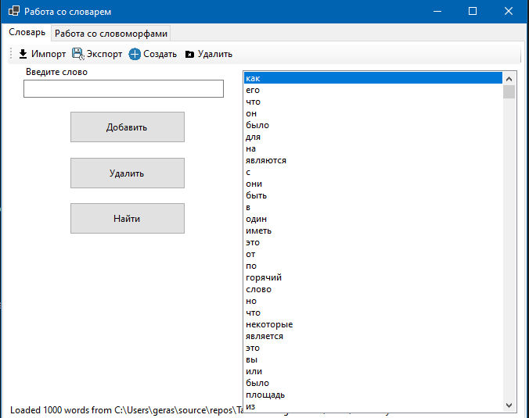
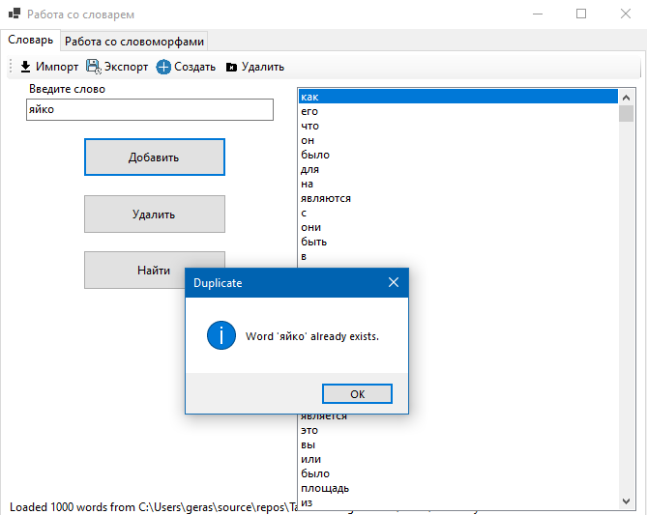

Рис.2-4 – Первая страница с редактированием словаря
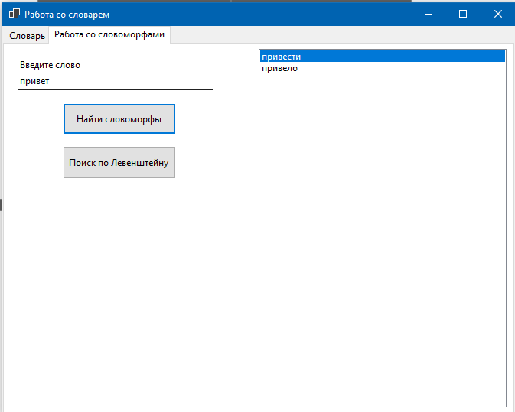
Рис.5 – Поиск словоморфов
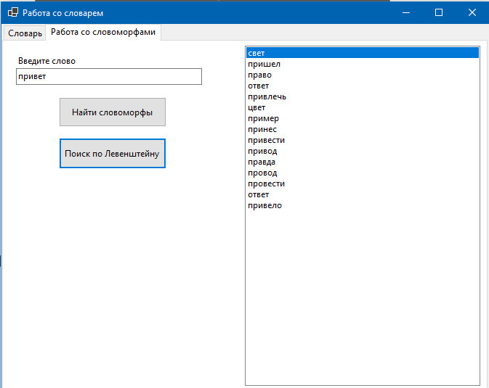
Рис.6 – Поиск слов по дистанции левенштейна<=3

